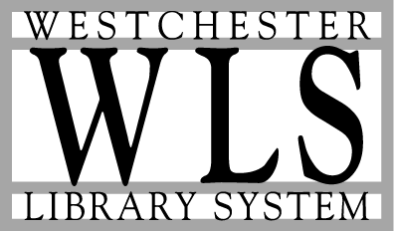

YOU ARE CORDIALLY INVITED…

A WESTCHESTER LIBRARY SYSTEM
TOWN MEETING

“National & Professional Trends Affecting the Library Community: The Future of Libraries and e-Business”

Louella Wetherbee
Library Management Consultant

Topics:
- How will the information revolution affect libraries?
- How will the library evolve as a modern workplace requiring
a new set of staff skills and expertise?
- What role will the continued demand for traditional library resources play in the networked world of the university, the community, schools, and business world?
- Which organizations and companies are best equipped to provide
emerging electronic services to libraries?

Wednesday, December 6, 2000
7:00 pm Refreshments ◊ 7:30 pm Program

WESTCHESTER LIBRARY SYSTEM
410 Saw Mill River Road
Ardsley, NY

RSVP: 914-674-3600, ext. 225 or e-mail eburke@wls.lib.ny.us
by December 4, 2000

